ASSIMENT 1
- Internet Mapping Activity: Draw a diagram showing how data travels across the internet from your computer to a friend's computer in another country. Label important elements like routers and servers.

ANSWERS
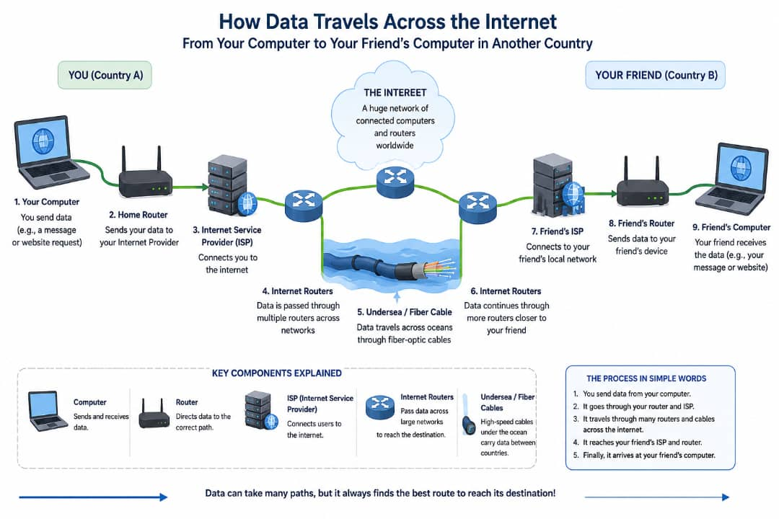
- COMPUTER: sends and receives data.
- ROUTER: Directs data to the correct destination.
- IPS (Internet service provider) : Connects users to internet.
- INTERNET ROUTERS: Pass data across networks.
- SERVERS (OPTIONAL): Store websites , emails , or online service that data may pass through.

2.Web Components Match: Match HTML, URL, and HTTP to their correct descriptions in an interactive classroom activity
ANSWER
- COMPONENT
HTML: the language used to create and structure web pages.
URL: the web address used to locate a website or webpage.
HTTP: the protocol that allows web browsers and servers to communicate and transfer web pages.
- CORRECT MACHES
HTML: Creates the structure of web pages.
URL: the address of a web page.
HTTP: Transfer web pages between browser and service.

